Title: safety and effectiveness of oral anticoagulant use in dialysis patients with atrial fibrillation or atrial flutter in Hong Kong: a target trial emulation

Abstract

Introduction
Atrial fibrillation (AF) and atrial flutter (AFL) are types of supraventricular arrhythmias associated with an increased risk of ischemic stroke. These conditions can result in the formation of blood clots within the atrium, which may subsequently travel to the brain, leading to cardiovascular morbidity and mortality. Given the elevated risk of thromboembolic events, guidelines recommend the long-term use of oral anticoagulants (OACs) in the general population with AF or AFL. Agents such as warfarin and direct oral anticoagulants (DOACs), including dabigatran, rivaroxaban, apixaban, and edoxaban, are advised based on clinicians' discretion for high-risk patients with a CHA2DS2VASc score of one or above.
AF and AFL are common in patients with kidney failure. AF incidence in this group ranges from 11.6% to 22.2%, about 11 times higher than in the general population. AF and kidney failure together increase stroke or embolic risk by 1.8 to 2-fold. The heightened risk is likely due to shared cardiovascular risk factors like heart failure, hypertension, and diabetes. In dialysis patients with AF, both thromboembolic and bleeding risks are elevated, increasing mortality. This complicates OAC administration decisions.
Warfarin and DOACs' efficacy in dialysis patients is uncertain due to lack of RCTs and conflicting observational studies. Safety concerns and questionable OAC effectiveness in reducing stroke risk in dialysis patients led the KDIGO 2011 guideline to advise against OAC use in AF patients on dialysis. The 2023 AHA guideline, on the other hand, suggested warfarin and apixaban as options, with a weak class 2B recommendation, implying lack of clarity on effectiveness and safety. To further complicate the matter, a PD-first policy has been adopted for all patients with kidney failure requiring dialysis unless medically contraindicated in Hong Kong. Different dialysis modalities exhibit differences in removal rate, duration, pharmacokinetic profiles, and heparin use.
In light of the ongoing debate regarding the use of OACs in PD patients with atrial AF, this study seeks to assess the safety and efficacy of OAC administration in PD patients using a population-based electronic medical database from Hong Kong.

Method

Target trial emulation with observational study design
We emulated a target randomized controlled trial to evaluate the comparative effectiveness and safety of OAC versus non-use in preventing stroke among peritoneal dialysis patients with atrial fibrillation or flutter from 2007 to 2022. This retrospective cohort study employed a sequential, propensity score-matched design to approximate randomization, aligning with the target trial framework. The specification on emulation with observational data and target trial were illustrated in Supplementary Table 1. Eligibility criteria were dynamically reassessed monthly and included individuals: 1) who are at end-stage renal failure and underwent peritoneal dialysis, 2) with a diagnosis of atrial fibrillation or atrial flutter; and 3) those without stroke diagnosis history at each month. From 2007 to 2022, a total of 191 sequential trials were conducted, each representing a monthly eligibility assessment window. Treatment assignment was determined by OAC initiation within one month preceding each trial. Those who had oral anticoagulants before the index date were considered as a new user, while the others were treated as non-users. And those non-users will be eligible for the subsequent trial.
Figure 1. Sequential trial design for emulating a target trial on the impact of oral anticoagulants on incident stroke on individuals underwent peritoneal dialysis
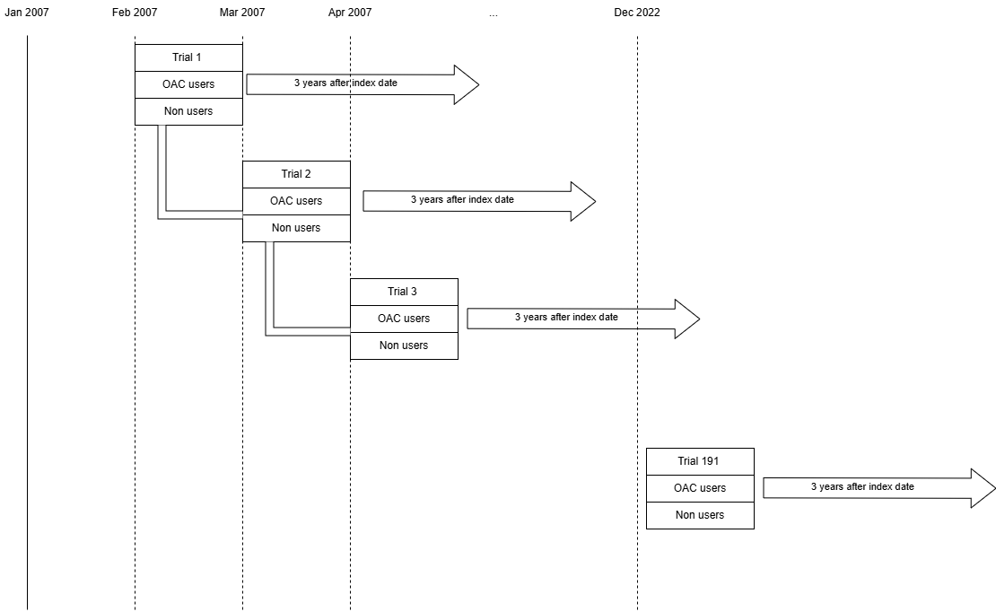

Data source
CDARS

Propensity score matching
Within each monthly trial, we performed 1:10 nearest-neighbor matching without replacement to balance baseline covariates between OAC initiators and non-users. The propensity score model incorporated: 1) Demographic variables (age at index date and sex); 2)Clinical factors (CHA₂DS₂-VASc score at index date, time since atrial fibrillation diagnosis); 3) Comorbidities (congestive heart failure, myocardial infarction, peripheral vascular disease, cerebrovascular disease, chronic obstructive pulmonary disease, dementia, paralysis, diabetes, mild liver disease, moderate-severe liver disease, ulcers, asthma, rheumatoid arthritis, malignancy, metastatic solid tumour, diabetes, hypertension, severe constipation); 3) antiplatelet use history before index date. Untreated participants can be matched to more than 1 treated participant within each trial. In the intention-to-treat analysis, the drug swithers will not be censored and will be kept in the analysis.

Outcome, exposure of interests and statistical analysis
Incident ischemic as effectiveness events and hemorrhagic strokes as safety event were identified through validated ICD-9-CM codes within a 3-year follow-up window. Cumulative risks of events were estimated via pooled logistic regression models adjusted with indicators of month of follow-up and the baseline covariates: age, sex, comorbidities of myocardial infarction, stroke, time from atrial fibrillation to index date, and monthly updated time-varying antiplatelet use history. Nonparametric bootstrapping with 500 samples is used to construct a 95 confidence interval.
Stratified analyses by sex and age (65 as cutoff) were conducted. We compared xxx as a negative outcome control within 3 years after the index date, which was not expected to be affected by oral anticoagulants. Three sensitivity analyses were conducted to evaluate the robustness of the estimation. First, we change the matching ratio from 1:10 to 1:4 with the nearest propensity scores within 0.2 standard deviations of the mean to reconduct the primary analysis. Second, a five-year instead of three-years risk were estimated. Third,

Results

Characteristics of the study population
We identified 311,712 individuals with end-stage renal failure between 2007 and 2022, of whom 8,851 met eligibility criteria for emulating a target trial comparing OAC use versus non-use in peritoneal dialysis patients with atrial fibrillation (Figure 2). Among eligible participants, 0.95% (84/8,851) were classified as OAC initiators. Baseline imbalances were evident before matching: OAC users exhibited a shorter median interval from atrial fibrillation diagnosis to index date (17 vs. 370 days) and a higher prevalence of myocardial infarction (29.8% vs. 16.7%) compared to non-users.
Propensity score matching achieved balance in most covariates, including demographics, comorbidities, and CHA₂DS₂-VASc scores (3.37 vs. 3.39). However, residual imbalances persisted in baseline antiplatelet use (71.0% vs. 80.1%) and time from atrial fibrillation diagnosis to index date (median 17 vs. 149.5 days). The matched cohort included 84 OAC users and 836 non-users, with comparable age (median 66.67 vs. 67.95 years) and sex distribution (50% male in both groups).

Stroke incidence rate with oral anticoagulants for AF patients who underwent peritoneal dialysis
Over an median 357 days (Interquatile range: 90 – 540 days), the cumulative incidence of ischemic stroke are similar between OAC group and non-user group. (risk difference: 0.10%, 95 CI: -0.05% to 0.27; risk ratio: 2.11, 95% CI：0.86 to 3.99). For haemorraghic stroke, the difference is statistical nonsignificant (risk difference: 0.01%, 95% CI: -0.23% to 0.16%; risk ratio: 2.27, 95% CI: 0.53 to 4.90). The cumulative incidence curves for two groups are shown in Figure 1. Most stratified analysis shown a similar results, illustrated in table 2, except that there is a significant difference for haemorraghic stroke among younger population who aged less than 65 (risk ratio: 6.29, 95% CI: 1.01 to 21.35). Similar estimation could be found in all sensitivity analysis.

Figure 1. Flow chart of eligible patients of the target trial with end-stage renal failure patients who underwent peritoneal dialysis, a Hong Kong CDARS database for the public from 2007 to 2022
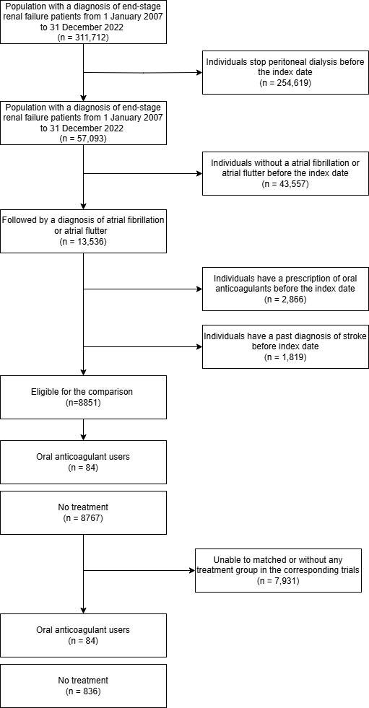

Table 1 Demographic information before and after the propensity score matching
Variables, n (%) | Before matching |  |  | After matching
 | Non-users  (N = 8767) | Users  (N = 84) | SMD | Non-users  (N = 836) | Users  (N = 84) | SMD
Follow-up period (median [IQR]) | 383.00 [161.00, 777.00] | 329.00 [132.00, 755.50] | 0.068 | 355.50 [142.50, 647.00] | 329.00 [132.00, 755.50] | 0.065
Sex, Male (%) | 4590 ( 52.4) | 42 ( 50.0) | 0.047 | 418 ( 50.0) | 42 ( 50.0) | <0.001
Age at index date (Years) (median [IQR]) | 68.32 [59.76, 75.97] | 66.67 [61.25, 73.53] | 0.027 | 67.95 [60.54, 75.51] | 66.67 [61.25, 73.53] | 0.013
Time from AF to Index date (Days) (median [IQR]) | 370.00 [154.50, 751.00] | 17.00 [8.75, 123.25] | 0.835 | 149.50 [64.00, 312.25] | 17.00 [8.75, 123.25] | 0.311
CHA₂DS₂-VASc Score (mean (SD)) | 3.32 (1.44) | 3.37 (1.48) | 0.030 | 3.39 (1.38) | 3.37 (1.48) | 0.016
Congestive Heart Failure | 2890 ( 33.0) | 30 ( 35.7) | 0.058 | 287 ( 34.3) | 30 ( 35.7) | 0.029
Myocardial infarction | 1463 ( 16.7) | 25 ( 29.8) | 0.313 | 224 ( 26.8) | 25 ( 29.8) | 0.066
Peripheral vascular disease | 920 ( 10.5) | 7 ( 8.3) | 0.074 | 75 ( 9.0) | 7 ( 8.3) | 0.023
Cerebrovascular disease | 1139 ( 13.0) | 9 ( 10.7) | 0.071 | 92 ( 11.0) | 9 ( 10.7) | 0.009
Chronic obstructive pulmonary disease | 1027 ( 11.7) | 7 ( 8.3) | 0.113 | 74 ( 8.9) | 7 ( 8.3) | 0.018
Dementia | 193 ( 2.2) | 1 ( 1.2) | 0.078 | 13 ( 1.6) | 1 ( 1.2) | 0.031
Paralysis | 77 ( 0.9) | 0 ( 0.0) | 0.133 | 1 ( 0.1) | 0 ( 0.0) | 0.049
Diabetes | 4660 ( 53.2) | 52 ( 61.9) | 0.178 | 511 ( 61.1) | 52 ( 61.9) | 0.016
Mild liver disease | 234 ( 2.7) | 2 ( 2.4) | 0.018 | 24 ( 2.9) | 2 ( 2.4) | 0.031
Moderate-severe liver disease | 74 ( 0.8) | 1 ( 1.2) | 0.035 | 4 ( 0.5) | 1 ( 1.2) | 0.078
Ulcers | 1286 ( 14.7) | 12 ( 14.3) | 0.011 | 118 ( 14.1) | 12 ( 14.3) | 0.005
Asthma | 368 ( 4.2) | 2 ( 2.4) | 0.102 | 11 ( 1.3) | 2 ( 2.4) | 0.079
Rheumatoid arthritis | 57 ( 0.7) | 1 ( 1.2) | 0.057 | 8 ( 1.0) | 1 ( 1.2) | 0.023
Malignancy | 851 ( 9.7) | 7 ( 8.3) | 0.048 | 55 ( 6.6) | 7 ( 8.3) | 0.067
Metastatic solid tumour | 48 ( 0.5) | 1 ( 1.2) | 0.069 | 4 ( 0.5) | 1 ( 1.2) | 0.078
Diabetes without chronic complication | 3734 ( 42.6) | 42 ( 50.0) | 0.149 | 409 ( 48.9) | 42 ( 50.0) | 0.022
Diabetes with chronic complication | 3331 ( 38.0) | 38 ( 45.2) | 0.147 | 373 ( 44.6) | 38 ( 45.2) | 0.012
Hypertension | 7668 ( 87.5) | 76 ( 90.5) | 0.096 | 736 ( 88.0) | 76 ( 90.5) | 0.079
Severe Constipation | 2386 ( 23.3) | 19 ( 17.4) | 0.146 | 155 ( 17.4) | 19 ( 17.8) | 0.011
Antiplatelet user history | 8042 ( 78.5) | 78 ( 71.6) | 0.161 | 715 ( 80.1) | 76 ( 71.0) | 0.211
Figure 2 Estimated risk of ischemic stroke (A) and haemorrhagic stroke (B) incidence over 3 years, by oral anticoagulants drug used or not, in end-stage renal failure with peritoneal dialysis, HK CDARS data 2007- 2022
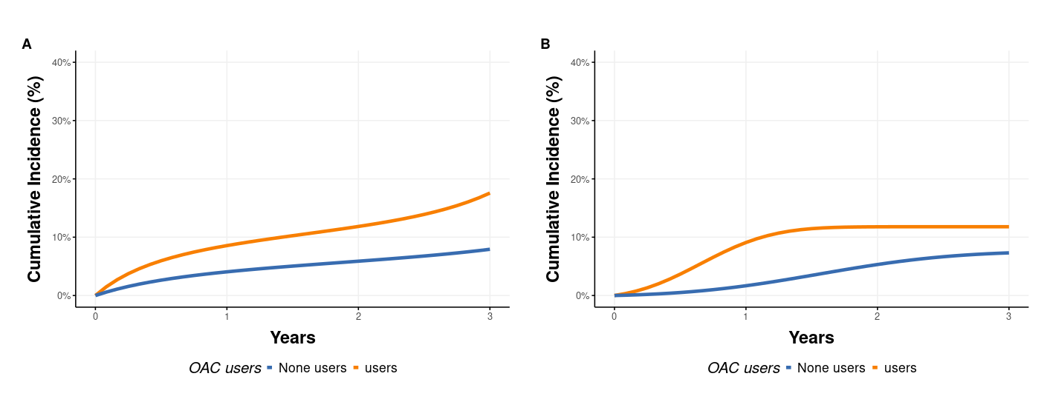
* A) Ischemic stroke and B) haemorraghic stroke

Table 2. Estimated 3-year risks of stroke in emulated target trials in end-stage renal failure with peritoneal dialysis, HK CDARS
 | Risk, % (95% CI) |  | Risk difference,% | Risk ratio
 | OAC non-users | OAC users
Composite outcome (death and stroke)
Primary analysis | 0.72 (0.70, 0.74) | 0.73 (0.62, 0.85) | 0.01 (-0.10, 0.13) | 1.05 (0.92, 1.18)
By sex
Male | 0.69 (0.67, 0.72) | 0.64 (0.48, 0.81) | -0.05 (-0.20, 0.12) | 0.96 (0.73, 1.19)
Female | 0.74 (0.71, 0.76) | 0.79 (0.61, 0.99) | 0.05 (-0.13, 0.26) | 1.10 (0.87, 1.27)
By age (years old)
<65 | 0.58 (0.55, 0.60) | 0.77 (0.61, 0.91) | 0.20 (0.03, 0.34) | 1.29 (1.05, 1.49)
>=65 | 0.79 (0.77, 0.81) | 0.71 (0.54, 0.89) | -0.09 (-0.25, 0.09) | 0.95 (0.76, 1.12)
All-cause mortality
Primary analysis | 0.63 (0.61, 0.64) | 0.58 (0.46, 0.71) | -0.04 (-0.17, 0.09) | 0.95 (0.77, 1.13)
By sex
Male | 0.6 (0.58, 0.62) | 0.56 (0.41, 0.73) | -0.04 (-0.19, 0.13) | 0.99 (0.74, 1.25)
Female | 0.64 (0.62, 0.66) | 0.54 (0.33, 0.83) | -0.1 (-0.31, 0.19) | 0.84 (0.55, 1.15)
By age (years old)
<65 | 0.46 (0.43, 0.49) | 0.54 (0.31, 0.73) | 0.08 (-0.15, 0.26) | 1.08 (0.68, 1.39)
>=65 | 0.71 (0.69, 0.73) | 0.6 (0.44, 0.77) | -0.11 (-0.28, 0.06) | 0.88 (0.66, 1.08)
Ischemic stroke
Primary analysis | 0.08 (0.05, 0.14) | 0.18 (0.05, 0.36) | 0.10 (-0.05, 0.27) | 2.11 (0.86, 3.99)
By sex
Male | 0.03 (0.00, 0.06) | 0.11 (0.00, 0.25) | 0.08 (-0.05, 0.21) | 4.06 (0.00, 10.83)
Female | 0.13 (0.07, 0.37) | 0.20 (0.05, 0.77) | 0.07 (-0.16, 0.53) | 1.48 (0.48, 3.27)
By age (years old)
<65 | 0.06 (0.02, 0.13) | 0.19 (0.03, 0.48) | 0.13 (-0.04, 0.41) | 2.81 (0.70, 8.41)
>=65 | 0.08 (0.05, 0.20) | 0.10 (0.01, 0.25) | 0.02 (-0.14, 0.18) | 1.49 (0.33, 3.61)
Hemorraghic stroke
Primary analysis | 0.07 (0.06, 0.09) | 0.09 (0.03, 0.20) | 0.02 (-0.05, 0.13) | 2.03 (0.75, 4.2)
By sex
Male | - | - | - | -
Female | 0.08 (0.06, 0.12) | 0.11 (0.02, 0.28) | 0.03 (-0.08, 0.2) | 2.55 (0.52, 5.12)
By age (years old)
<65 | - | - | - | -
>=65 | 0.07 (0.05, 0.1) | 0.04 (0, 0.11) | -0.04 (-0.09, 0.04) | 0.86 (0, 2.78)
Composite outcome (Hemorraghic stroke, GI and other bleeding)
Primary analysis | 0.09 (0.07, 0.11) | 0.09 (0.03, 0.2) | 0 (-0.07, 0.11) | 1.63 (0.63, 3.29)
By sex
Male | - | - | - | -
Female | 0.09 (0.06, 0.12) | 0.11 (0.02, 0.27) | 0.02 (-0.08, 0.19) | 2.4 (0.5, 4.92)
By age (years old)
<65 | - | - | - | -
>=65 | 0.1 (0.07, 0.12) | 0.03 (0, 0.11) | -0.06 (-0.12, 0.02) | 0.64 (0, 1.97)
Note: Standardised by age, sex,
The 3-year risks under each screening strategy can be obtained via the discrete hazards (pooled logistic) regression model for the monthly probability of the outcome:

Table 3.Summary of the protocol of a target trial for studying the safety and effectiveness of oral coagulants in dialysis patients with atrial fibrillation or atrial flutter, and summary of the target trial is emulated using HK CDARS data.
Protocol component | Target trial | Emulation of the target trial using HK CDARS data
Eligibility criteria | People with end-stage renal failure undergoing peritoneal dialysis with a diagnosis of atrial fibrillation or atrial flutter aged 18 or older and who have not used oral coagulants. | The target trial is emulated using data in CDARS on people who were diagnosis with end-stage renal failure undergoing peritoneal dialysis with a newly diagnosis of atrial fibrillation or atrial flutter between 2007 and 2022. The emulation is performed using sequential trials approaches. At a given montly from 2007 to 2022, an individual is defined as meeting the eligibility criteria if they meet the following conditions:  - Age 18 or older;  - Still underwent peritoneal dialysis;  - With a diagnosis of atrial fibrillation or atrial flutter before index date;  - Without any OAC prescription record before two months till 1993;  - Without hemodialysis, renal transplant before  The first visit at which the trial emulation eligibility criteria are met in the available data is denoted 𝑘=0 and subsequent trial times are 𝑘=1,2,…. The maximum number of trial is 191, with 𝑘=191 corresponding to the index date of 2022-12-01.
Treatment strategies | (i) Do not start using OAC.  (ii) Start using OAC. | The treatment strategies of interest are as in the target trial. The individuals who start to receive OAC within one month before the index date are treated as OAC users, while those without started OAC are treated as OAC non-users.
Assignment procedures | Patients randomly assigned to either treatment strategy. | At each trial, an individual is an OAC user or non‐user. A propensity score matching was used to emulate the randomization of eligible person-trials at baseline, where the users and non-users were matched in a 1:10 ratio within each trial. The nearest neighbour propensity score matching without replacement, with a propensity score estimated using logistic regression of the treatment on the covariates. The matching factors included demographic characteristics (sex and age at index), and baseline commorbidities, in addition to the baseline antiplatelet use within each trial for the emulation.
Follow‐up period | Starts at randomization and ends at death, stop peritoneal dialysis, start of hemodialysis, or renal transplant, loss‐to follow‐up, or 3 years of follow‐up, whichever occurs first. | Follow‐up starts at each index date and ends at death or transplant, the end of 2022, or 3-years after index date, whichever occurs first.
Outcome | For safety events, ischemic stroke or death  For effectiveness, haemorrhagic stroke | As in the target trial.
Causal contrasts | Intention to treat effect. The patients will be assigned according to their assignment at baseline, no matter the change during follow-up.  Per protocol treatment effect. Marginal survival curves up to 11 years under the two treatment strategies, and corresponding marginal risk differences. For the marginal probabilities, the population of interest is individuals meeting the target trial eligibility criteria in 2018. | The causal contrasts of interest are as in the target trial. Estimation uses the propensity score matching approach and the approach of the sequential trial.

Discussion

References

Supplementary materials

Sensitivity analysis
 | Risk, % (95% CI) |  | Risk difference,% | Risk ratio
 | OAC non-users | OAC users
Ischemic stroke
Study period from 3 to 5 years | 0.17 (0.09, 0.40) | 0.22 (0.09, 0.51) | 0.05 (-0.21, 0.28) | 1.84 (0.78, 3.15)
Exposures assessment window change | 0.08 (0.05, 0.14) | 0.18 (0.07, 0.36) | 0.10 (-0.04, 0.28) | 2.11 (0.87, 4.05)
Hemorraghic stroke
Study period from 3 to 5 years | 0.15 (0.04, 0.71) | 0.12 (0.03, 0.27) | -0.03 (-0.52, 0.13) | 2.39 (0.80, 6.21)
Exposures assessment window change | 0.12 (0.05, 0.41) | 0.13 (0.02, 0.29) | 0.01 (-0.23, 0.16) | 0.13 (0.02, 0.29)
Note: Standardised by age, sex,

